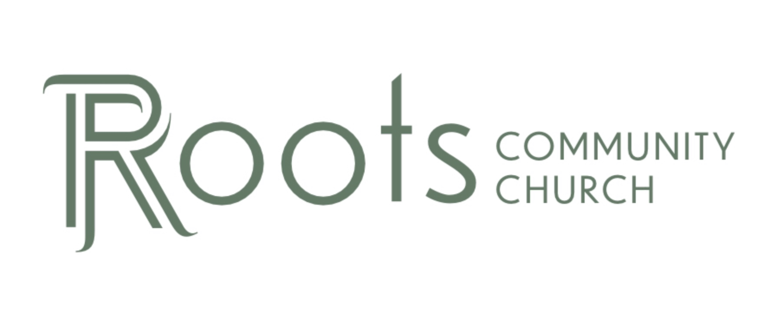

RCC Phoenix – 1.30.22 – Armor of God (Week 4)

Ephesians 6:10-18 NLT
A final word: Be strong in the Lord and in his mighty power. Put on all of God’s armor so that you will be able to stand firm against all strategies of the devil. For we are not fighting against flesh-and-blood enemies, but against evil rulers and authorities of the unseen world, against mighty powers in this dark world, and against evil spirits in the heavenly places. Therefore, put on every piece of God’s armor so you will be able to resist the enemy in the time of evil. Then after the battle you will still be standing firm. Stand your ground, putting on the belt of truth and the body armor of God’s righteousness. For shoes, put on the peace that comes from the Good News so that you will be fully prepared. In addition to all of these, hold up the shield of faith to stop the fiery arrows of the devil. Put on salvation as your helmet, and take the sword of the Spirit, which is the word of God. Pray in the Spirit at all times and on every occasion. Stay alert and be persistent in your prayers for all believers everywhere.

The Breastplate of Righteousness

Facts About the Breastplate:

- It was worn over a tunic that was normally ________________ in color.
- They chose this color since the dye was made from readily available ________________ and was very inexpensive.
- The breastplate went through several iterations but developed into ________________ ________________ in Jesus lifetime. It was very expensive to make and repair.
- The breastplate covered all ________________ ________________.

What is Righteousness?

Modern Dictionary Definition of Righteousness: ________________ that is morally justifiable or right.

Definition of Biblical Word for Righteousness: (Dikaiosune)
- in a broad sense: the condition ________________ to God
- the doctrine concerning the way in which man may attain a state ________________ of God
- integrity, ________________, purity of life, rightness, correctness of thinking feeling, and acting
Are Human Beings Righteous in Themselves?

Isaiah 64:6 NLT
We are all infected and impure with sin. When we display our righteous deeds, they are nothing but filthy rags. Like autumn leaves, we wither and fall, and our sins sweep us away like the wind.

Isaiah likens Sin to an infection. Bible scholars believe he is referencing the disease of ________________.

CDC Description of Hansen’s Disease:
The disease can affect the nerves, skin, eyes, and lining of the nose. The bacteria attack the nerves, which can become swollen under the skin. This can cause the affected areas to lose the ability to sense touch and pain, which can lead to injuries, like cuts and burns… If left untreated, the nerve damage can result in paralysis of hands and feet. In very advanced cases, the person may have multiple injuries due to lack of sensation, and eventually the body may reabsorb the affected digits over time, resulting in the apparent loss of toes and fingers. Corneal ulcers and blindness can also occur if facial nerves are affected. Other signs of advanced Hansen’s disease may include loss of eyebrows and saddle-nose deformity resulting from damage to the nasal septum.

Filthy Rags: A reference to the ____________ a woman used during her menstrual cycle.

Whose Righteousness Do We Put On?

Romans 3:19-24 NIV
“Now we know that whatever the law says, it says to those who are under the law, so that every mouth may be silenced and the whole world held accountable to God. Therefore no one will be declared righteous in God’s sight by the works of the law; rather, through the law we become conscious of our sin. But now apart from the law the righteousness of God has been made known, to which the Law and the Prophets testify. This righteousness is given through faith in Jesus Christ to all who believe. There is no difference between Jew and Gentile, for all have sinned and fall short of the glory of God, and all are justified freely by his grace through the redemption that came by Christ Jesus.”

The ________________ righteousness of God is freely given to every single person who has faith in Jesus Christ!

How do we put on the Breastplate of Righteousness?

- Put on God’s way of ________________

Philippians 4:8 NLT
“And now, dear brothers and sisters, one final thing. Fix your thoughts on what is true, and honorable, and right, and pure, and lovely, and admirable. Think about things that are excellent and worthy of praise.”

- Put on God’s way of ________________

Matthew 20:24-28 NLT
“When the ten other disciples heard what James and John had asked, they were indignant. But Jesus called them together and said, “You know that the rulers in this world lord it over their people, and officials flaunt their authority over those under them. But among you it will be different. Whoever wants to be a leader among you must be your servant, and whoever wants to be first among you must become your slave. For even the Son of Man came not to be served but to serve others and to give his life as a ransom for many.”

- Use the teachings of Jesus to define ________________

1 Corinthians 6:9-11 NLT
“Don’t you realize that those who do wrong will not inherit the Kingdom of God? Don’t fool yourselves. Those who indulge in sexual sin, or who worship idols, or commit adultery, or are male prostitutes, or practice homosexuality, or are thieves, or greedy people, or drunkards, or are abusive, or cheat people—none of these will inherit the Kingdom of God. Some of you were once like that. But you were cleansed; you were made holy; you were made right with God by calling on the name of the Lord Jesus Christ and by the Spirit of our God.”

- ____________ in the way Scripture guides us.

Matthew 7:12 NLT
“Do to others whatever you would like them to do to you. This is the essence of all that is taught in the law and the prophets.”

Matthew 22:37-39 NLT
“Jesus replied, “‘You must love the Lord your God with all your heart, all your soul, and all your mind.’ This is the first and greatest commandment. A second is equally important: ‘Love your neighbor as yourself.”

God’s righteousness is both ____________ to us and ________________ in us.

