RCC Phoenix – 2.7.21 – Philippians (Week 1)

- ________________ Our Life to Christ

There is a Difference between being ________________ and committing our life to Christ

There is a difference between being saved and being a ________________

Hebrews‬ 6:1-3‬ NIV‬‬‬‬
“Therefore, let us move beyond the elementary teachings about Christ and be taken forward to maturity, not laying again the foundation of repentance from acts that lead to death, and of faith in God, instruction about cleansing rites, the laying on of hands, the resurrection of the dead, and eternal judgment. And God permitting, we will do so.”
‬

- Ask God to Reveal Our ________________

Our purpose is always a _____________ _____________ of God’s greater purpose

1 Timothy‬ 2:3-4‬ NLT‬‬‬‬
“This is good and pleases God our Savior, who wants everyone to be saved and to understand the truth.”

Our purpose is never ________ - ______________

Our purpose serves __________, serves ___________ and _____________ people to Jesus

Matthew‬ 22:36-40‬ NLT‬‬‬‬
“Teacher, which is the most important commandment in the law of Moses?” Jesus replied, “‘You must love the LORD your God with all your heart, all your soul, and all your mind.’ This is the first and greatest commandment. A second is equally important: ‘Love your neighbor as yourself.’ The entire law and all the demands of the prophets are based on these two commandments.”

Our gifts are ________________ our purpose. They are a ________________ that carries our purpose and message to others.

The goal of our gifts and talents is to bring attention and action to our purpose

- Act in ________________

Paul immediately started preaching but it caused chaos.
Acts 9:19-31‬ NLT‬‬‬‬
“Afterward he ate some food and regained his strength. Saul stayed with the believers in Damascus for a few days. And immediately he began preaching about Jesus in the synagogues, saying, “He is indeed the Son of God!” All who heard him were amazed. “Isn’t this the same man who caused such devastation among Jesus’ followers in Jerusalem?” they asked. “And didn’t he come here to arrest them and take them in chains to the leading priests?” Saul’s preaching became more and more powerful, and the Jews in Damascus couldn’t refute his proofs that Jesus was indeed the Messiah. After a while some of the Jews plotted together to kill him. They were watching for him day and night at the city gate so they could murder him, but Saul was told about their plot. So during the night, some of the other believers lowered him in a large basket through an opening in the city wall. When Saul arrived in Jerusalem, he tried to meet with the believers, but they were all afraid of him. They did not believe he had truly become a believer! Then Barnabas brought him to the apostles and told them how Saul had seen the Lord on the way to Damascus and how the Lord had spoken to Saul. He also told them that Saul had preached boldly in the name of Jesus in Damascus. So Saul stayed with the apostles and went all around Jerusalem with them, preaching boldly in the name of the Lord. He debated with some Greek-speaking Jews, but they tried to murder him. When the believers heard about this, they took him down to Caesarea and sent him away to Tarsus, his hometown. The church then had peace throughout Judea, Galilee, and Samaria, and it became stronger as the believers lived in the fear of the Lord. And with the encouragement of the Holy Spirit, it also grew in numbers.”

Paul had to go home to Tarsus and ____________.

When we wait, God prepares ________, ____________ and the right ___________________.

When the time came, the Lord opened an opportunity for Paul to begin acting on his purpose (Acts 11).

- ________________ God’s Lead

Paul was saved, had committed his life to Christ, understood his purpose, acted in obedience, began preaching the Gospel to the Gentiles. But how did Paul know where to go?

Acts 16:1-12‬ NLT‬‬‬‬‬‬‬‬‬‬‬‬‬‬
“Paul went first to Derbe and then to Lystra, where there was a young disciple named Timothy. His mother was a Jewish believer, but his father was a Greek. Timothy was well thought of by the believers in Lystra and Iconium, so Paul wanted him to join them on their journey. In deference to the Jews of the area, he arranged for Timothy to be circumcised before they left, for everyone knew that his father was a Greek. Then they went from town to town, instructing the believers to follow the decisions made by the apostles and elders in Jerusalem. So the churches were strengthened in their faith and grew larger every day. Next Paul and Silas traveled through the area of Phrygia and Galatia, because the Holy Spirit had prevented them from preaching the word in the province of Asia at that time. Then coming to the borders of Mysia, they headed north for the province of Bithynia, but again the Spirit of Jesus did not allow them to go there. So instead, they went on through Mysia to the seaport of Troas. That night Paul had a vision: A man from Macedonia in northern Greece was standing there, pleading with him, “Come over to Macedonia and help us!” So we decided to leave for Macedonia at once, having concluded that God was calling us to preach the Good News there. We boarded a boat at Troas and sailed straight across to the island of Samothrace, and the next day we landed at Neapolis. From there we reached Philippi, a major city of that district of Macedonia and a Roman colony. And we stayed there several days.”
- You're probably not working ________________

Paul traveled with Barnabas, Mark, Silas, Timothy and many others.

- Paul submitted his ________________ to the Lord

Paul decided to go to Asia. The Lord said no.

Paul decided to go to Bithynia. The Lord said no.

Paul had a vision to go to Macedonia.

The Lord ________________ the right direction.

- Paul followed God’s ________________

Paul concluded that because of his closed doors and the Lord’s confirmation, that they were being ________________ to Philippi.

Ephesians 4:11-12 ESV
“And he gave the apostles, the prophets, the evangelists, the shepherds and teachers, to equip the saints for the work of ministry, for building up the body of Christ,”

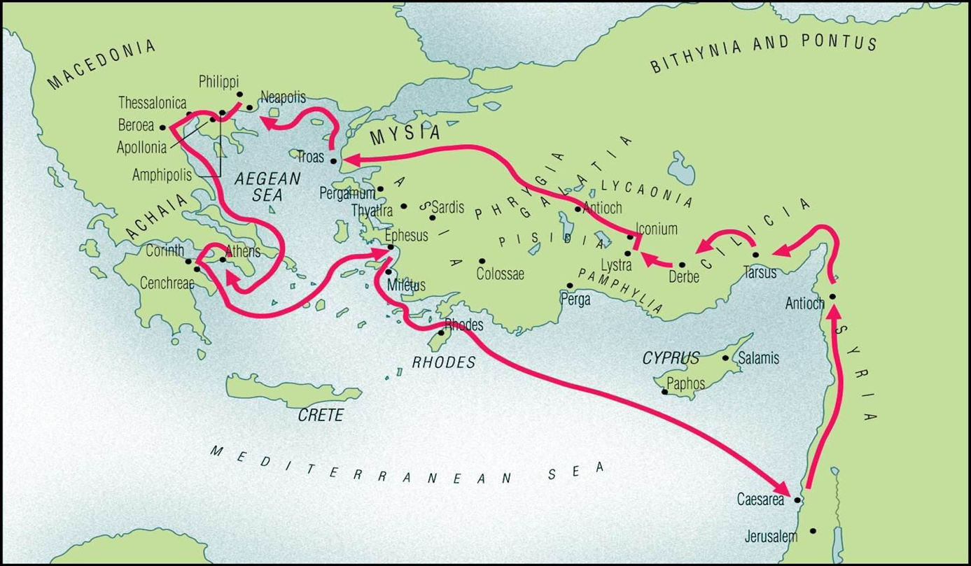
Calling – The place and method God desires for us to fulfill our part of His purpose.

