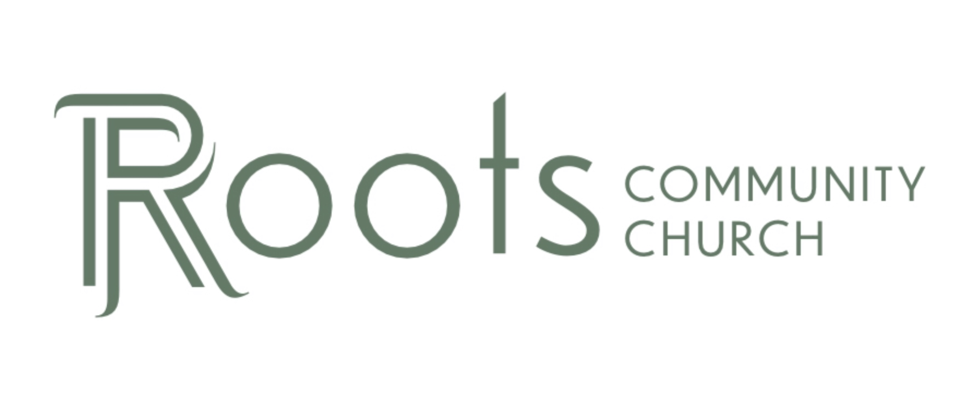

RCC Phoenix – 3.29.20 – Worship (Week 5)

This is not a message specific to the Corona Virus. It doesn’t have to be. Why?

The principles of worship apply at any time!

There are 2 time to worship God.

- When we ____________________ ____________________ it.
- When we ____________________.

Physical Expressions of Worship

- ____________________ ____________________

Psalms‬ 95:1-7‬ NLT‬‬‬‬‬‬‬‬‬‬
“Come, let us sing to the Lord! Let us shout joyfully to the Rock of our salvation. Let us come to him with thanksgiving. Let us sing psalms of praise to him. For the Lord is a great God, a great King above all gods. He holds in his hands the depths of the earth and the mightiest mountains. The sea belongs to him, for he made it. His hands formed the dry land, too. Come, let us worship and bow down. Let us kneel before the Lord our maker, for he is our God. We are the people he watches over, the flock under his care…”
‬‬‬‬‬‬‬‬

The act of kneeling is an outward expression of ____________________ to Almighty God.

- ____________________ Our ____________________

The people of Israel lived in a culture of ____________________.

There were 2 mandatory sacrifices: the _____________ offering and the ____________________ offering.

They then had the option of giving an additional ____________________ offering which was a specific type of sacrifice showing love, appreciation and gratitude to the Lord.

Psalms‬ 141:1-4‬ NLT‬‬‬‬‬‬‬‬‬‬
“O Lord, I am calling to you. Please hurry! Listen when I cry to you for help! Accept my prayer as incense offered to you, and my upraised hands as an evening offering. Take control of what I say, O Lord, and guard my lips. Don’t let me drift toward evil or take part in acts of wickedness. Don’t let me share in the delicacies of those who do wrong.”

- Lifting our hands is an ____________________ to the Lord
‬‬‬‬‬‬‬‬

The writer of Psalms here is asking for the action of lifted hands to be received as an additional offering, a statement of love, appreciation & gratitude to the Lord.

When we lift our hand we are making that same statement.

- Lifting our hands is ____________________ we need help and our ____________________ on the Lord.

- ____________________ Our ____________________

Psalms‬ 47:1-4‬ NLT‬‬‬‬‬‬‬‬
(For the Choir Director. A psalm from the decedents of Korah)
“Come, everyone! Clap your hands! Shout to God with joyful praise! For the Lord Most High is awesome. He is the great King of all the earth. He subdues the nations before us, putting our enemies beneath our feet. He chose the Promised Land as our inheritance, the proud possession of Jacob’s descendants, whom he loves.”
‬‬‬‬‬‬‬‬

Korah staged a ____________________ with 250 other men and opposed the leadership of Moses & Aaron over Israel (Numbers 16)

The Lord had the ground swallow them up

These are the decedents who wrote this Psalm.

Yet another example of how the Lord can transform those who were full of ____________________ into ____________________ of God Almighty, Jehovah!

“For the Lord Most High is ____________________.”

Has God ever showed up for you in an Awesome way? We should clap and applaud His greatness!

A Goal: While we are asked to stay home let’s turn our homes into places of ____________________.

