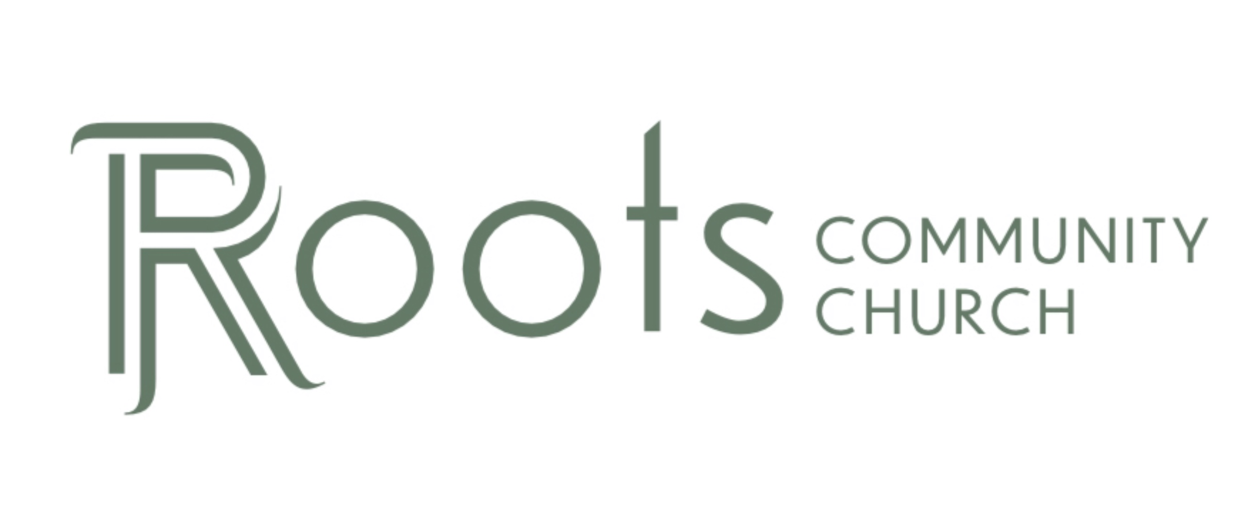

RCC Phoenix – 5.1.22 – The Bible (Week 2)

There is ________________ times more evidence available for the New Testament than any other ancient author, dating ________________ years earlier than any other ancient author.

- How do we know the Bible hasn’t been ________________ with?

Isaiah 53:1-12 NIV
“Who has believed our message and to whom has the arm of the Lord been revealed? He grew up before him like a tender shoot, and like a root out of dry ground. He had no beauty or majesty to attract us to him, nothing in his appearance that we should desire him. He was despised and rejected by mankind, a man of suffering, and familiar with pain. Like one from whom people hide their faces he was despised, and we held him in low esteem. Surely he took up our pain and bore our suffering, yet we considered him punished by God, stricken by him, and afflicted. But he was pierced for our transgressions, he was crushed for our iniquities; the punishment that brought us peace was on him, and by his wounds we are healed. We all, like sheep, have gone astray, each of us has turned to our own way; and the Lord has laid on him the iniquity of us all. He was oppressed and afflicted, yet he did not open his mouth; he was led like a lamb to the slaughter, and as a sheep before its shearers is silent, so he did not open his mouth. By oppression and judgment he was taken away. Yet who of his generation protested? For he was cut off from the land of the living; for the transgression of my people he was punished. He was assigned a grave with the wicked, and with the rich in his death, though he had done no violence, nor was any deceit in his mouth. Yet it was the Lord ’s will to crush him and cause him to suffer, and though the Lord makes his life an offering for sin, he will see his offspring and prolong his days, and the will of the Lord will prosper in his hand. After he has suffered, he will see the light of life and be satisfied; by his knowledge my righteous servant will justify many, and he will bear their iniquities. Therefore I will give him a portion among the great, and he will divide the spoils with the strong, because he poured out his life unto death, and was numbered with the transgressors. For he bore the sin of many, and made intercession for the transgressors.”

The Prophet Isaiah lived around ________________ BC.

The earliest copy of the book of Isaiah in our possession was dated to ________________ AD.

In 1947 a young man discovered a cave with many clay jars containing ancient scrolls that we refer to today as the ________________ ________________ ________________. Archeologists found 11 caves in total with scrolls and fragments.
These scrolls contained copies of many ancient writings. 40% of the Dead Sea Scrolls were of Old Testament books (including the book of Isaiah). The scrolls were dated to ________________ BC.

The scrolls provided further evidence that the book of Isaiah was written ________________ Jesus lived so the prophecies were not invented after he lived. They actually show Jesus fulfilled every prophecy from 700 years earlier.

- How Do We Know the Scribes / Copies Are ________________?

Another benefit of the Dead Sea Scrolls is we can also now test how accurate the copies were from more than 2100 years ago until now.

The Book of Isaiah Copies/Dates:
- Dead Sea Scrolls: 125 BC
- Aleppo Codex: 950 AD
- Modern Bible: Current Day

Norman Geisler – Biblical Theologian:
“Of the 166 words in Isaiah 53, only 17 letters in question. 10 of these letters are simply a matter of spelling which does not affect the sense (meaning). Four more letters are stylistic changes such as conjunctions. The remaining 3 letters comprise the word “light” which was added in verse 11 and does not affect the meaning greatly.”

After ________________ years of unknown multiple scribes copying Isaiah, there are only 3 letters difference from Isaiah 53 and those 3 letters do not change the meaning of the passage.

That’s a ___________ accuracy rate.

What About the New Testament?

We do not have the ________________ copies of the New Testament writings and letters.

The original New Testament writings were written on pieces of ________________ and disintegrated over time from corrosion, exposure to the elements and continued handling.

Papyrus was made from Papyrus ________________.

There are ________________ of textual variants between the copies of the New Testament. In fact, there are so many variants, no two copies are identical or agree with each other completely.

99.8% of the variants are ________________ related.

Text Variant Example(s):

Romans 1:17 NKJV
“For in it the righteousness of God is revealed from faith to faith; as it is written, “The just shall live by faith.”

Important: None of these remaining variants impact any core, essential or foundational doctrine in the Bible.

Example 1:

A major New Testament variant is the ending of the Book of _______________ (chapter 16).

Most scholars agree that the longer ending of Mark 16 (verses 9-19) is not part of the original writing and was added later.

Example 2:

Mark 9:29 NKJV
“So He said to them, “This kind can come out by nothing but prayer and fasting.”

The oldest manuscript of Mark does not ________________ the last 2 words “…and fasting.”

Example 3:

Revelation 13:18 NKJV
“Here is wisdom. Let him who has understanding calculate the number of the beast, for it is the number of a man: His number is 666.”

The oldest manuscript of Revelation shows the number of man listed is ________________.

Biblical Scholars freely admit the scribes who copied the Scriptures were not absolutely perfect in their writing.

Misquoting Jesus – Bart Ehrman (paperback edition pg. 252 - appendix)
Q: “Why do you believe these core tenets of Christian orthodoxy to be in jeopardy based on the scribal errors you discovered in the biblical manuscripts?”

BE: “Essential Christian beliefs are not affected by textual variants in the manuscript tradition of the New Testament.”

-Sir Frederic Kenyon, Paleographer Extraordinaire Principal Librarian, British Museum
“The general result of all these discoveries and all this study is to strengthen the proof of the authenticity of the Scriptures, and our conviction that we have in our hands, in substantial integrity, the veritable Word of God.

- How Many Essential Doctrines of the Christian Faith are Impacted by the Text Variants?

________________

Colossians 2:1-4 NLT
“I want you to know how much I have agonized for you and for the church at Laodicea, and for many other believers who have never met me personally. I want them to be encouraged and knit together by strong ties of love. I want them to have complete confidence that they understand God’s mysterious plan, which is Christ himself. In him lie hidden all the treasures of wisdom and knowledge. I am telling you this so no one will deceive you with well-crafted arguments.”

