RCC Phoenix – 5.24.20 – 4H - HANDS (Week 2)

Last week we began our series called 4H – The Real Work of Relationship.

Any relationship worth keeping requires work.

Since the greatest relationship we will ever encounter is with God through faith in Jesus, we need to be willing to do the work necessary to remove the things that would kill the Word of God growing in us and express our love to God through following His commands.

The first “H” is the ____________________.

Our head is the environment where our thoughts grow.

2 Corinthians‬ 10:3-5‬ ESV‬‬‬‬‬‬‬‬‬‬‬‬‬‬
“For though we walk in the flesh, we are not waging war according to the flesh. For the weapons of our warfare are not of the flesh but have divine power to destroy strongholds. We destroy arguments and every lofty opinion raised against the knowledge of God, and take every thought captive to obey Christ,”

What is a ____________________?

Dr. Caroline Leaf is a neuroscientist who is a believer in Christ.

- Thoughts Are ____________________.

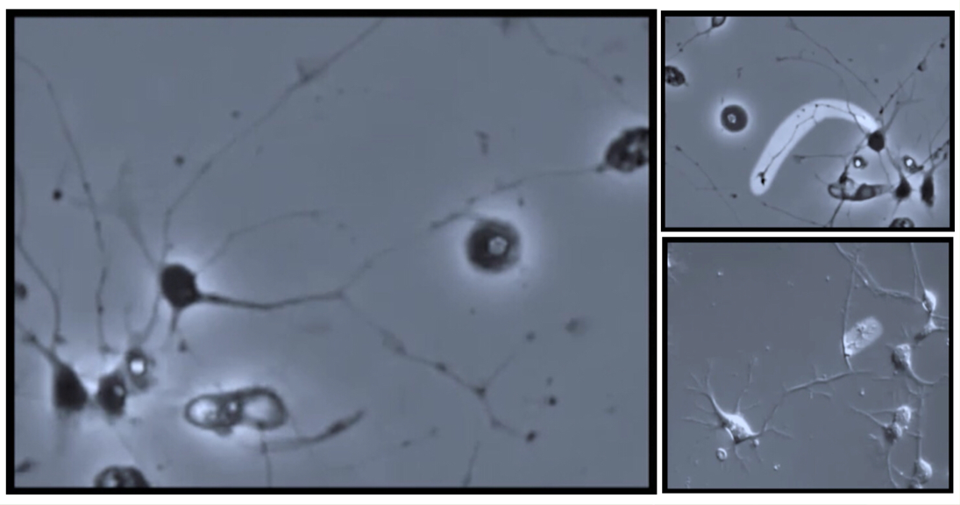
There is a physical portion of your brain reserved shot term memories and when you have a thought, a microscopic tree like growth takes place. This tree like growth is called a Dendrite.

A thought literally becomes a physical thing that takes up mental real estate in your brain.

Let’s look at some facts from Dr. Leaf’s research about our brain:

- A thought stays in ____________________ memory for approximately 1-2 days.
- Spending 7-10 minutes thinking about ideas/concepts ____________________ the brains growth to that memory.
- After 21 days of thought the memory is moved into ____________________ term memory.
- After 63 days (three 21 day cycles) the thought becomes a ____________________.
- It takes 21-28 days to break down ____________________ habits.

As a man thinks in His heart, so is he. (Proverbs 23:7)

The original word in Proverbs 23:7 for “heart” is a general word for the heart, will, soul, attitude and ____________________.

- What We ____________________ on, Grows.

Philippians‬ 4:8 KJV‬‬‬‬‬‬‬‬‬‬‬‬‬‬‬‬‬‬
“Finally, brethren, whatsoever things are true, whatsoever things are honest, whatsoever things are just, whatsoever things are pure, whatsoever things are lovely, whatsoever things are of good report; if there be any virtue, and if there be any praise, think on these things.

Philippians‬ 4:8 NLT‬‬‬‬‬‬‬‬‬‬
‬‬‬‬‬‬‬‬‬‬‬‬‬‬‬‬‬‬‬‬‬‬‬‬‬‬‬‬‬‬‬‬‬‬‬‬‬‬‬‬‬‬“And now, dear brothers and sisters, one final thing. Fix your thoughts on what is true, and honorable, and right, and pure, and lovely, and admirable. Think about things that are excellent and worthy of praise.”‬‬‬‬‬‬‬‬

Question – Do we spend time thinking on things that should be encouraged or celebrated according to Scripture?

Scripture tells us we have a ____________________ regarding our thoughts.

Ephesians‬ 4:17-24‬ NLT‬‬‬‬‬‬‬‬‬‬
“With the Lord’s authority I say this: Live no longer as the Gentiles do, for they are hopelessly confused. Their minds are full of darkness; they wander far from the life God gives because they have closed their minds and hardened their hearts against him. They have no sense of shame. They live for lustful pleasure and eagerly practice every kind of impurity. But that isn’t what you learned about Christ. Since you have heard about Jesus and have learned the truth that comes from him, throw off your old sinful nature and your former way of life, which is corrupted by lust and deception. Instead, let the Spirit renew your thoughts and attitudes. Put on your new nature, created to be like God—truly righteous and holy.”

- Our Mind is ____________________ by God’s Word.

Philippians‬ 4:8 KJV‬‬‬‬‬‬‬‬‬‬
“Finally, brethren, whatsoever things are true, whatsoever things are honest, whatsoever things are just, whatsoever things are pure, whatsoever things are lovely, whatsoever things are of good report; if there be any virtue, and if there be any praise, think on these things. Those things, which ye have both learned, and received, and heard, and seen in me, do: and the God of peace shall be with you.”

This verse gives us 6 categories of thoughts we are encouraged to spend time and effort thinking about.

True – John 14:6 - Jesus is the way the _______________ and the life
Honest – Numbers 23:19 - God is not a man that He should _______________
Just – Micah 6:8 - Act _______________, love mercy, walk humbly with your God
Pure – Psalm 51:10 – Create in me a _______________ heart oh God and renew a right spirit within me
Lovely – Psalm 84:1 – How _______________ is your dwelling place oh Lord…
Good Report – Acts 14:7 – And there they preached the _______________ News

A Counseling Center in Florida put a chart and definitions together outlining the imp[act our thoughts have on our feelings and behavior.

Thoughts are comprised of information that our brain takes in and sends to our mind. Our mind acts as the gatekeeper of the computed information. It determines which information is relevant and thus what will become our mental focus. Those thoughts can very easily become beliefs that can affect our feelings in positive or negative ways.
Feelings are the emotional response to thoughts and behaviors.
Behaviors are the actions generated from our thoughts and feelings.

Thoughts have a direct impact on ____________________ and ____________________.

What happens when believers in Christ spend their time thinking on what Scripture tells us?

Philippians‬ 4:9‬ NLT‬‬‬‬‬‬‬‬‬‬
“Keep putting into practice all you learned and received from me—everything you heard from me and saw me doing. Then the God of peace will be with you.”
‬‬‬‬‬‬‬‬

Question: Are there any ways of thinking we currently have that we need to remove and/or ask the Lord to help us remove?

