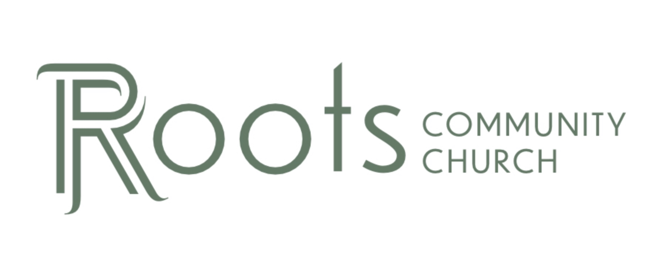

RCC Phoenix – 5.29.22 – The Bible (Week 4)

- Why is it Important to have the Bible in Our Own ________________?

Many church leaders lived immoral lifestyles and justified it by ________________ Scripture.

The Bible was presented by the catholic church leaders in ________________.

The priests were the only ones who could read the language so only they could tell the people what the Bible said. This was used as a form of ________________.

Since ____________, translating the Bible into English was considered a capital offense that could result in ________________.

It was also illegal to:
- Possess an ________________translation of the Bible.
- Have any books printed ________________the Bible.
- Have children recite the ________________ ________________in English.

One major advantage to having the Bible in our own language is we do not need ________________ ________________ to learn about God.

1 Timothy 2:5-6 NLT
“For, There is one God and one Mediator who can reconcile God and humanity—the man Christ Jesus. He gave his life to purchase freedom for everyone. This is the message God gave to the world at just the right time.”

- How did we get the ________________ Bible?

We owe a huge debt of gratitude to ________________Tyndale.

Tyndale moved to London in 1523 to ask the ________________of London for permission to translate Bible into English.

Tyndale then moved to ________________ and completed the English translation of the New Testament in 1525.

During that period, most of the people in England could not read or write but would gather in ________________ to have those who were literate read the Scripture out loud.

This led to the people realizing the Catholic priests taught them ________________ ideas.

More than ____________ of KJV Bible directly quotes Tyndale’s translation.

