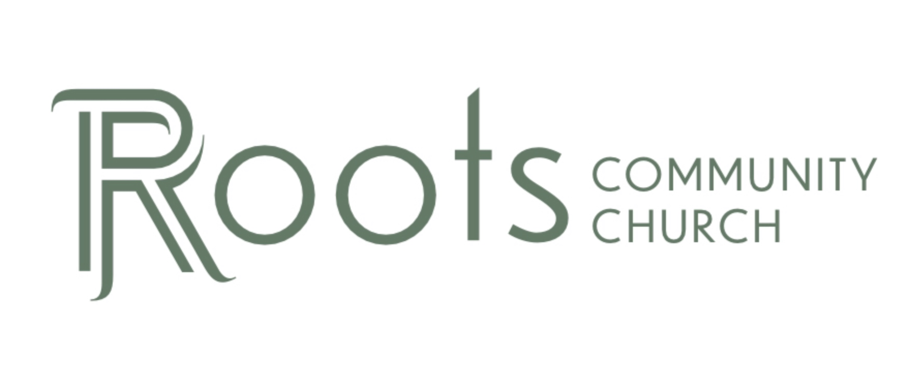

RCC Phoenix – 6.20.21 – Philippians (Week 16) The Injection Point

Week 1: How Paul was _________ to Philippi
- The Lord ________________ the steps of those committed to Him

Week 2: Paul’s ________________ to the Lord
- Paul compares serving the Lord ________________ Slavery

Week 3: The city of Philippi was created for ________________ members of the Italian Military
- Standing up for the Gospel ________________ become more difficult

Week 4: Paul was constantly chained to a member of the ________________ Guard
- God is working in the midst of our ________________ circumstances

Week 5: Paul expects and hopes to never be ________________ of the Gospel
- We are capable of terrible behavior when our hearts are not ________________ to Christ.

Week 6: Paul reminds us that we are ________________ of Heaven
- Our goal is to live on Earth as Christ ________________

Week 7: Paul asks ________ questions
- We are to use our gift to ________________ God and each other

Week 8: Paul admonishes us to work hard to show the results of our ________________ & obey God with ________________
- “Fear” of God is not being _____________ of Him but showing a deep sense of awe for our Lord.

Week 9: Paul shows us that God will change our ________________
- God transforms our old, selfish desires into new desires that will satisfy the purposes of God and shine the light of the ________________ to the world

Week 10: Paul writes about his ________________
- Godly friends who encourage us to ________________ following Jesus even when things are difficult are a blessing to us.

Week 11: Paul tells us to ________________ our faith
- We don’t follow the old law (circumcision) to earn salvation through following the rules. We stand confident that God gives us ________________ through our faith in Jesus Christ and it can be trusted.

Week 12: Paul instructs us to press ________________ in our pursuit of Jesus
- We do not keep the old life alive by focusing on it and trying to prevent our old wounds from healing.

Week 13: Paul points us to ________________
- Believers can disagree on ________________ issues and still be in fellowship with other believers.

Week 14: Paul gives specific instructions for ________________ a dispute
- Commit to be ________________ and to not allow division to grow in our hearts or church fellowship.

Week 15: Paul teaches us about true ________________
- We learned to not take Philippians 4:13 or 19 out of ________________.

Week 16: God will put us in the ________________ place to accomplish His purpose.

The Roman Empire needed a way to travel & facilitate commerce between Rome and their farthest boarders so the Romans became very effective ________________ builders.

In the 2nd century BC, a famous Roman roadway was constructed called the ________________ Way.

It connected to another road system called the Persian ________________ Road.

- God will lead us to the ________________ place to accomplish His purpose.

Philippi was in the ________________ of the Egnatian Way and a frequent stop for many travelers.

The Lord directed you to RCC. He orchestrated you being in your career field. He knows who you have relationships with in life. ________________ are the injection point of the Gospel to your world.

- Our hearts must remain submitted to Christ so what flows out of us correctly ________________ our Savior.

What are we ________________ to those in our sphere of influence? The ________________ of our life is what others will sample. If we have ________________ in Christ, we will produce good fruit.

- God will ________________ us to other people and avenues to continue the spread of the Gospel.

The message of the Gospel will ________________ long after we are gone. Our job is to ________________ the message of Christ in as many places as possible with the fruit of our lives.

