RCC Phoenix – 6.7.20 – 4H – HANDS (Week 4)

‬‬‬‬‬‬‬‬‬‬‬‬‬‬‬‬‬‬The 3rd “H” in our 4H series – ________________ which represent our ________________. ‬‬‬‬‬‬

Luke‬ 10:25-37‬ NLT‬‬‬‬‬‬‬‬‬‬‬‬‬‬‬‬‬‬
“One day an expert in religious law stood up to test Jesus by asking him this question: “Teacher, what should I do to inherit eternal life?” Jesus replied, “What does the law of Moses say? How do you read it?” The man answered, “‘You must love the Lord your God with all your heart, all your soul, all your strength, and all your mind.’ And, ‘Love your neighbor as yourself.’” “Right!” Jesus told him. “Do this and you will live!” The man wanted to justify his actions, so he asked Jesus, “And who is my neighbor?” Jesus replied with a story: “A Jewish man was traveling from Jerusalem down to Jericho, and he was attacked by bandits. They stripped him of his clothes, beat him up, and left him half dead beside the road. “By chance a priest came along. But when he saw the man lying there, he crossed to the other side of the road and passed him by. A Temple assistant walked over and looked at him lying there, but he also passed by on the other side. “Then a despised Samaritan came along, and when he saw the man, he felt compassion for him. Going over to him, the Samaritan soothed his wounds with olive oil and wine and bandaged them. Then he put the man on his own donkey and took him to an inn, where he took care of him. The next day he handed the innkeeper two silver coins, telling him, ‘Take care of this man. If his bill runs higher than this, I’ll pay you the next time I’m here.’ “Now which of these three would you say was a neighbor to the man who was attacked by bandits?” Jesus asked. The man replied, “The one who showed him mercy.” Then Jesus said, “Yes, now go and do the same.”

The Bible doesn’t specify what the lawyer’s actions were but the implication is they were lacking ________________ because he was trying to justify them to Jesus.

Jesus puts the actions of the lawyer on ________________ and uses his own words as the testimony to implicate and instruct him.

It’s important to note that the man who was left on the side of the road was a ________________.

Jews and Samaritans ________________ each other.

The animosity dated back to before Israel settled in Canaan and escalated from there. They were constantly at war with each other, torching each other’s ________________ and warring over land.

Jews and Samaritans viewed each other with ________________ & prejudice.

So for the Samaritan to care for the Jew was a MASSIVE act that ________________ his own national prejudices and care for his fellow man.
- Hands that ________________ Others

1 Peter‬ 4:10-11‬ NLT‬‬‬‬‬‬‬‬‬‬‬‬‬‬‬‬‬‬
“God has given each of you a gift from his great variety of spiritual gifts. Use them well to serve one another. Do you have the gift of speaking? Then speak as though God himself were speaking through you. Do you have the gift of helping others? Do it with all the strength and energy that God supplies. Then everything you do will bring glory to God through Jesus Christ. All glory and power to him forever and ever! Amen.”

The word “Serve” in the Original Language of the Bible: Diakoneo
Definitions of Diakoneo:
- To Minister
- Attend to anything that may serve another’s interest
- Word Picture: To wait a ________________ and offer food and drink to the guest
If you don’t have the gift of speaking or helping others, then use the ________________ God gave you to serve each other and the world.

If you are a…
- Painter, paint the message God has put on your ________________.
- Singer, sing the songs of God’s ________________.
- Writer, write the words to reflect the the ________________ of God, His Son and His Word.
- Builder, build your business, brand or structure with the utmost ________________.
- Worker, work as if you were ________________ our Lord.

Colossians‬ 3:22-24‬ AMP‬‬‬‬‬‬‬‬‬‬‬‬‬‬‬‬‬‬
“Servants, in everything obey those who are your masters on earth, not only with external service, as those who merely please people, but with sincerity of heart because of your fear of the Lord. Whatever you do [whatever your task may be], work from the soul [that is, put in your very best effort], as [something done] for the Lord and not for men, knowing [with all certainty] that it is from the Lord [not from men] that you will receive the inheritance which is your [greatest] reward. It is the Lord Christ whom you [actually] serve.”
- Hands that Care for the ________________ of Others

Jesus parable of the Good Samaritan shows the ________________ of God and how He desires for believers in Christ to act.

Psalms‬ 147:3‬ NLT‬‬ - “He heals the brokenhearted and bandages their wounds.”‬‬‬‬‬‬‬‬‬‬‬‬‬‬‬‬

Proverbs‬ 6:16-19‬ NLT‬‬ - “There are six things the Lord hates— no, seven things he detests: haughty eyes, a lying tongue, hands that kill the innocent, a heart that plots evil, feet that race to do wrong, a false witness who pours out lies, a person who sows discord in a family.”‬‬‬‬‬‬‬‬‬‬‬‬‬‬‬‬

Isaiah‬ 61:1-2‬ NLT‬‬ - “The Spirit of the Sovereign Lord is upon me, for the Lord has anointed me to bring good news to the poor. He has sent me to comfort the brokenhearted and to proclaim that captives will be released and prisoners will be freed. He has sent me to tell those who mourn that the time of the Lord’s favor has come, and with it, the day of God’s anger against their enemies.”‬‬‬‬‬‬‬‬‬‬‬‬‬‬‬‬

Jonah‬ 4:2‬ NLT‬‬ - “…I knew that you are a merciful and compassionate God, slow to get angry and filled with unfailing love. You are eager to turn back from destroying people.”‬‬‬‬‬‬‬‬‬‬‬‬‬‬‬‬

Can we buy a bag of groceries for a family that’s hurting financially?
Can we be present with someone who is hurting from loosing a friend or relative?
Can we clean the house of someone who is hurting physically from being injured?
Can we give a sandwich to a homeless person who is hurting from not having work?

1 John‬ 3:16-19‬ NLT‬‬‬‬‬‬‬‬‬‬‬‬‬‬‬‬‬‬
“We know what real love is because Jesus gave up his life for us. So we also ought to give up our lives for our brothers and sisters. If someone has enough money to live well and sees a brother or sister in need but shows no compassion—how can God’s love be in that person? Dear children, let’s not merely say that we love each other; let us show the truth by our actions. Our actions will show that we belong to the truth, so we will be confident when we stand before God.”

These acts of love and compassion for the wounds and needs of others, show the love of Christ crosses all human ________________ and seeks to shine the light of the Gospel in dark places.

- Hands that ____________ Up & ____________ Others

Galatians‬ 6:1-3‬ NLT‬‬‬‬‬‬‬‬‬‬‬‬‬‬‬‬‬‬
“Dear brothers and sisters, if another believer is overcome by some sin, you who are godly should gently and humbly help that person back onto the right path. And be careful not to fall into the same temptation yourself. Share each other’s burdens, and in this way obey the law of Christ. If you think you are too important to help someone, you are only fooling yourself. You are not that important.”

Adam Clarke Biblical Commentary:
Share each others burdens : “Have sympathy; feel for each other; and consider the case of a ________________ brother as your own.”

The church should be the world’s example for this kind of ________________.

“It’s hard to hate _____ ______________.”

A story about the Queen of England.
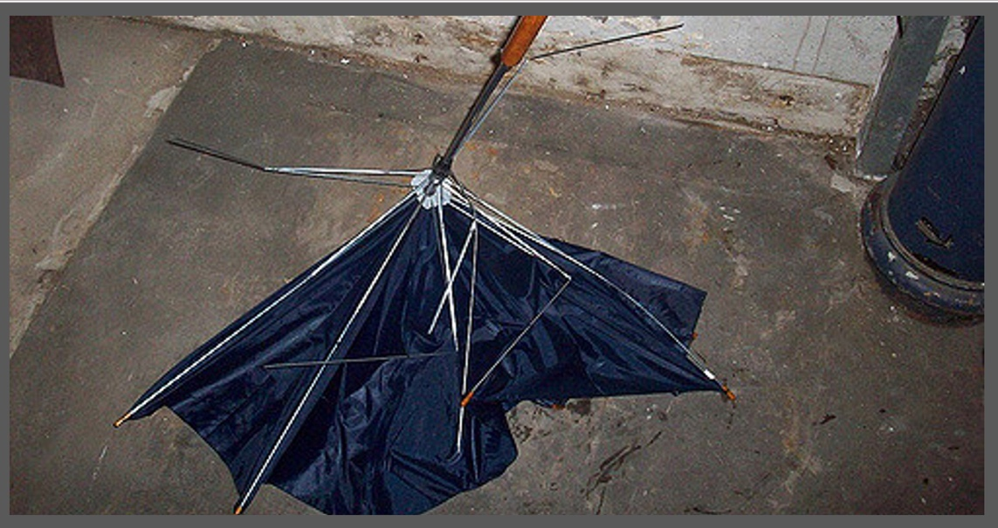
“Had I only known it was the Queen, I would have given my best.”

I want us to avoid having to say:
Had I only known my actions meant so much…
Had I only known my words could heal such hurt…
Had I only known my anger eclipsed my compassion…
Had I only known my faith included my action…

Action is using our hands to serve ________________, caring for the needs of ________________ and/or carrying ________________ who truly have needs.

If we only use our hands (our actions) to serve our own interests, line our own pockets, build monuments to our own achievements, applaud our own successes and hold on to hatred, our hands are ________________ by the very weeds we should remove from the garden of our actions.

As Believers, let us use our hands to remove the weeds growing in our actions and then turn to the Kingdom minded business of serving others over ourselves.

